Matthew Jusino

Software Setup

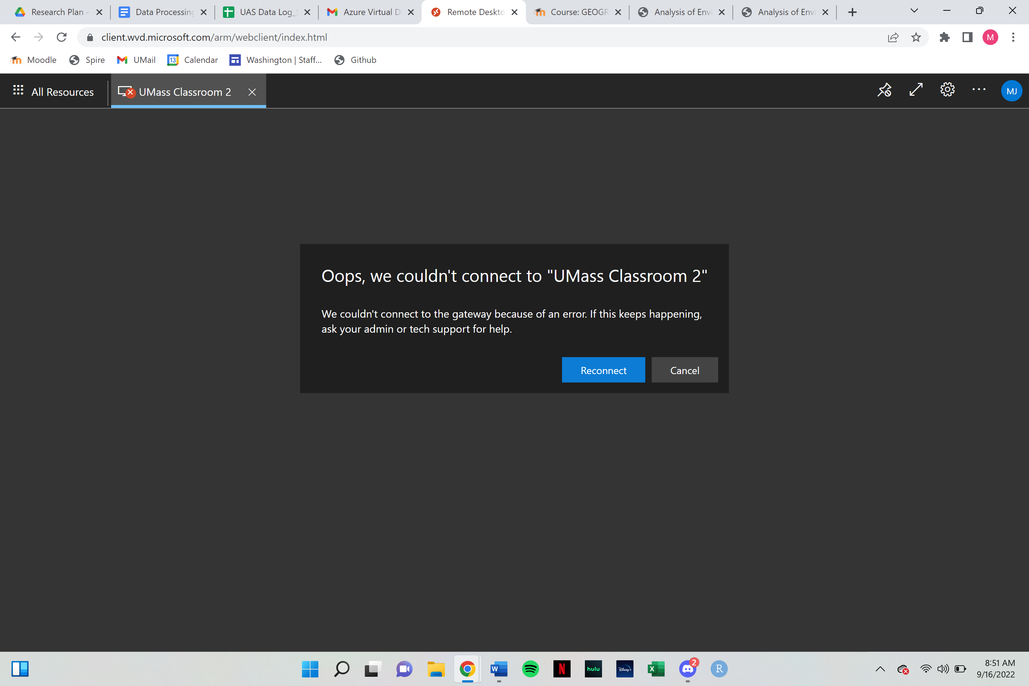

While I was unable to connect to AVD due to a gateway error, I did successfully gain access to the software

